Database | Query | Number of Studies
PubMed | ("centenarians"[MeSH Terms] OR "centenarians"[All Fields] OR "centenarian"[All Fields]) AND ("sars cov 2"[MeSH Terms] OR "sars cov 2"[All Fields] OR "covid"[All Fields] OR "covid 19"[MeSH Terms] OR "covid 19"[All Fields]) | 34
Scopus | ( TITLE-ABS-KEY ( centenarian AND covid ) ) OR ( TITLE-ABS-KEY ( *supercentenarian* OR semi*supercentenarian ) AND ORIG-LOAD-DATE AFT 20240314 ) AND ( LIMIT-TO ( DOCTYPE , "ar" ) OR LIMIT-TO ( DOCTYPE , "no" ) OR LIMIT-TO ( DOCTYPE , "cp" ) OR LIMIT-TO ( DOCTYPE , "sh" ) OR LIMIT-TO ( DOCTYPE , "le" ) OR LIMIT-TO ( DOCTYPE , "ed" ) ) | 29
Web of Science | (ALL=(centenarian)) AND ALL=(covid) | 38
Supplementary Table 1: Search Strategy.

Author, Pub Yr | Study | Region | Centenarian (Case) |  |  | Other Older Adults (Control)
Author, Pub Yr | Study | Region | Case | Case Death | Mortality % | Control | Control Death | Mortality %
Couderc, et al. [27] | Retro-spective, cohort | 15 nursing homes in Marseille, France | 12 | 6 | 50.00 | 309 | 66 | 21.36
Gallert, et al. [28] | Retro-spective, cohort | LTCF, Germany | 8264 | 40 | 0.48 | 403725 | 5,493 | 1.36
Cruces, et al. [29] | Population based, case-control | Basques country, Spain | 325 | 95 | 29.23 | 21,170 | 4,977 | 23.51
Claudia, et al. [30] | Population based, cohort | Columbia | 1,005 | 373 | 37.11 | 6,312,867 | 3,508,691 | 55.58
Supplementary Table 2: Details of Studies Meeting Inclusion Criteria.

Centenarian Group |  |  |  | Other Older Adults
Raw Proportion | ci.lb | ci.ub | pval | Raw Proportion | ci.lb | ci.ub | pval
0.28 | 0.03 | 0.53 | 0.03 | 0.25 | -0.12 | 0.63 | 0.18
Logit Proportion | ci.lb | ci.ub | pval | Logit Proportion | ci.lb | ci.ub | pval
0.15 | 0.02 | 0.61 | 0.12 | 0.16 | 0.02 | 0.7 | 0.19
Arcsine Proportion | ci.lb | ci.ub | pval | Arcsine Proportion | ci.lb | ci.ub | pval
0.24 | 0.01 | 0.62 | 0.01 | 0.22 | 0 | 0.69 | 0.05
Supplementary Table 3: Comparison between Raw, Logit and Arcsine Proportions.

Pred | ci.lb | ci.ub | Pi.Ib | Pi.ub
0.81 | 0.47 | 1.38 | 0.26 | 2.47

Pooled RD | ci.lb | ci.ub | p-val
81% | 0.47 | 1.38 | 0.43
Supplementary Table 4: Pooled Mortality OR across all Studies.

Pred | ci.lb | ci.ub | Pi.Ib | Pi.ub
0.99 | 0.93 | 1.05 | 0.88 | 1.11

Pooled RD | ci.lb | ci.ub | p-val
99% | 0.93 | 1.05 | 0.69
Supplementary Table 5: Pooled Mortality RD across all Studies.

Arcsine Proportion | ci.lb | ci.ub | p-val
0.24 | 0.01 | 0.62 | 0.01
Supplementary Table 6: Pooled Mortality Estimate for Centenarians.

Arcsine Proportion | ci.lb | ci.ub | p-val
0.22 | 0 | 0.69 | 0.05
Supplementary Table 7: Pooled Mortality Estimate for Other Older Adults.

Pred | ci.lb | ci.ub | Pi.Ib | Pi.ub
0.86 | 0.14 | 5.40 | 0.04 | 19.10

Pooled OR | ci.lb | ci.ub | p-val
86% | 0.14 | 5.40 | 0.87
Supplementary Table 8: Pooled Odds Ratio for LTCF.

Pred | ci.lb | ci.ub | Pi.Ib | Pi.ub
1.04 | 0.90 | 1.20 | 0.83 | 1.29

Pooled RD | ci.lb | ci.ub | p-val
1.04 | 0.90 | 1.20 | 0.62
Supplementary Table 9: Pooled Risk Difference for LTCF.

Pred | ci.lb | ci.ub | Pi.Ib | Pi.ub
0.94 | 0.49 | 1.66 | 0.32 | 2.55

Pooled OR | ci.lb | ci.ub | p-val
90% | 0.49 | 1.66 | 0.75
Supplementary Table 10: Pooled Odds Ratio for Home Dwelling Centenarians.

pred | ci.lb | ci.ub | pi.lb | pi.ub
0.97 | 0.86 | 1.10 | 0.79 | 1.20

Pooled OR | ci.lb | ci.ub | p-val
97% | 0.86 | 1.10 | 0.67
Supplementary Table 11: Pooled Risk Difference for Home Dwelling Centenarians.

pred | ci.lb | ci.ub | pi.lb | pi.ub
0.94 | 0.34 | 2.64 | 0.13 | 6.83

Pooled RD | ci.lb | ci.ub | p-value
94% | 0.34 | 2.64 | 0.91
Supplementary Table 12: Pooled Odds Ratio for Centenarians in Developed Countries.

pred | ci.lb | ci.ub | pi.lb | pi.ub
1.02 | 0.97 | 1.06 | 0.94 | 1.10

Pooled RD | ci.lb | ci.ub | p-value
1.02 | 0.97 | 1.06 | 0.51
Supplementary Table 13: Pooled Risk Difference for Centenarians in Developed Countries.

 | Study | Q1 | Q2 | Q3 | Q4 | Q5 | Q6 | Q7 | Q8 | Q9 | Q10
1 | Cruses, et al. 2024
Note: Q1 Were the groups comparable other than the presence of disease in cases or the absence of disease in controls?
Q2 Were cases and controls matched appropriately?
Q3 Were the same criteria used for identification of cases and controls?
Q4 Was exposure measured in a standard, valid and reliable way?
Q5 Was exposure measured in the same way for cases and controls?
Q6 Were confounding factors identified?
Q7 Were strategies to deal with confounding factors stated?
Q8 Were outcomes assessed in a standard, valid and reliable way for cases and controls?
Q9 Was the exposure period of interest long enough to be meaningful?
Q10 Was appropriate statistical analysis used?
Key
Yes
No
NA
Supplementary Table 14: Critical Appraisal Tool for Case Control Studies.

 | Study | Q1 | Q2 | Q3 | Q4 | Q5 | Q6 | Q7 | Q8 | Q9 | Q10 | Q11
1 | Couderc, et al. [27]
2 | Gellert, et al. [28]
3 | Claudia, et al. [30]
Note: Q1 Were the two groups similar and recruited from the same population?
Q2 Were the exposures measured similarly to assign people to both exposed and unexposed groups?
Q3 Was the exposure measured in a valid and reliable way?
Q4 Were confounding factors identified?
Q5 Were strategies to deal with confounding factors stated?
Q6 Were the groups/participants free of the outcome at the start of the study?
Q7 Were the outcomes measured in a valid and reliable way?
Q8 Was the follow up time reported and sufficient to be long enough for outcomes to occur?
Q9 Was follow up complete, if not, were the reasons to loss to follow up described and explored?
Q10 Were strategies to address incomplete follow up utilized?
Q11 Was appropriate statistical analysis used?
Key
Yes
No
NA
Supplementary Table 15: Critical Appraisal Tool for Cohort Studies.

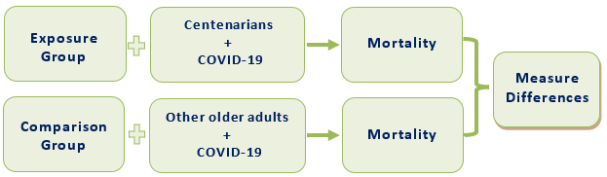
Supplementary Figure 1: PICOS (population, intervention, comparison, outcomes and study) design for eligibility criteria.

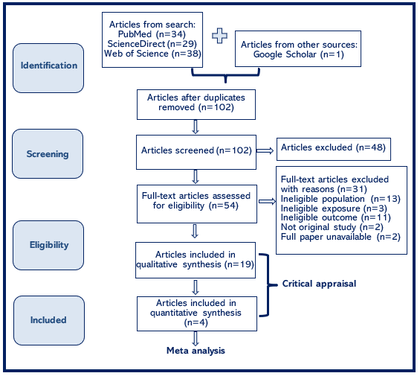
Supplementary Figure 2: PRISMA (Preferred Reporting Items for Systematic review and Meta-Analyses) Flowchart.

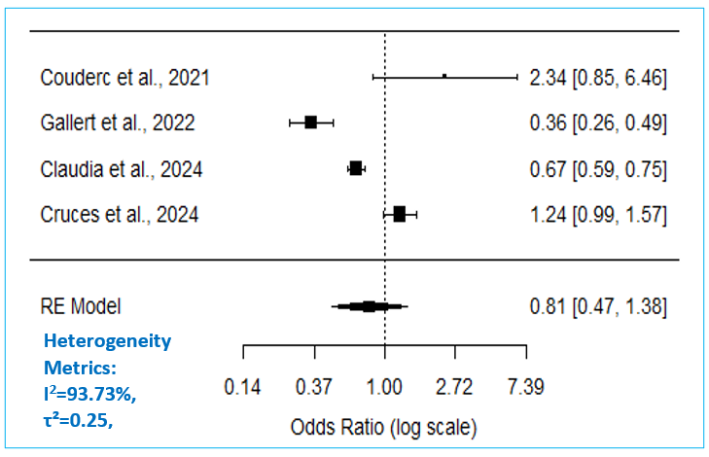
Supplementary Figure 3: Forest Plot Depicting Pooled Odds Ratio of COVID-19 Mortality.

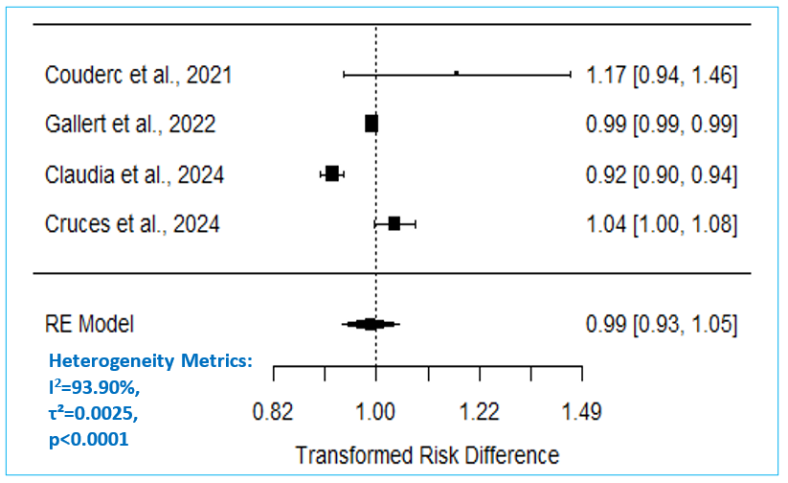
Supplementary Figure 4: Forest Plot Depicting Risk Difference of COVID-19 Mortality.

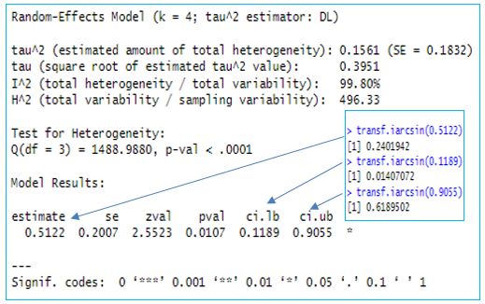
Supplementary Figure 5: Pooled Mortality Estimate for Centenarians, DerSimonian-Laird RE Model.

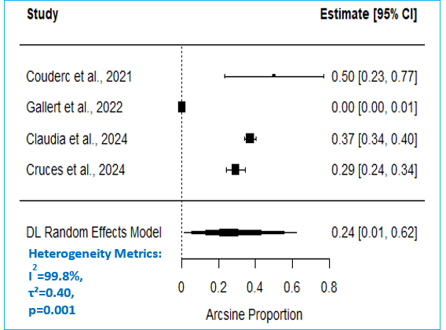
Supplementary Figure 6: Forest Plot Depicting Mortality Proportion in Centenarians.

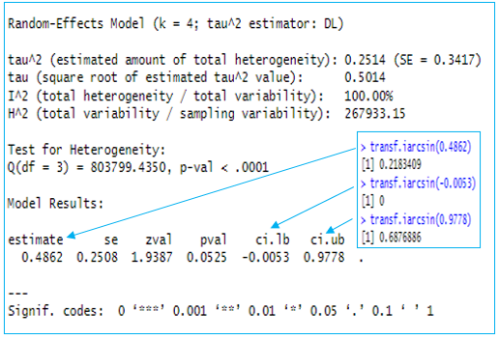
Supplementary Figure 7: Pooled Mortality Estimate for Other Older Adults, DerSimonian-Laird RE Model.

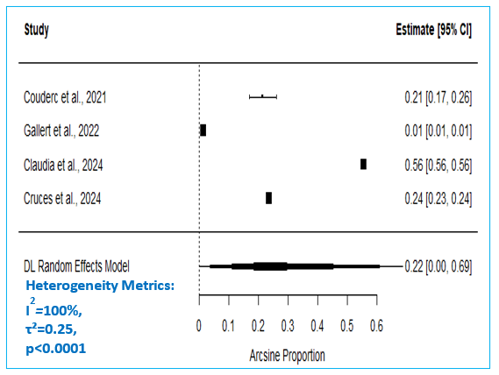
Supplementary Figure 8: Forest Plot Depicting Mortality Proportion in Other Older Adults.

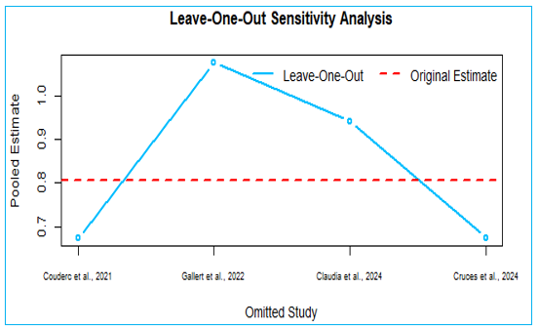
Supplementary Figure 9: Leave-One-Out Sensitivity Analysis.

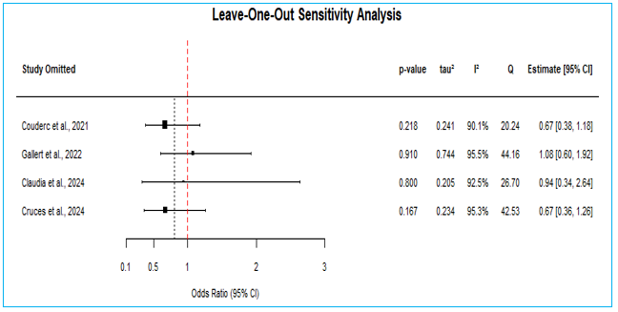
Supplementary Figure 10: Leave-One-Out Forest Plot.

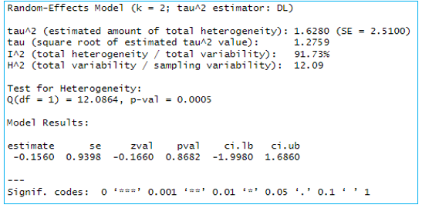
Supplementary Figure 11: LTCF Pooled Odds Ratio, DerSimonian-Laird Model.

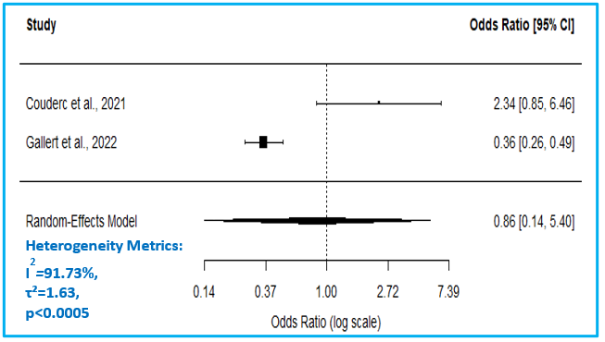
Supplementary Figure 12: LTCF Odds Ratio Forest Plot.

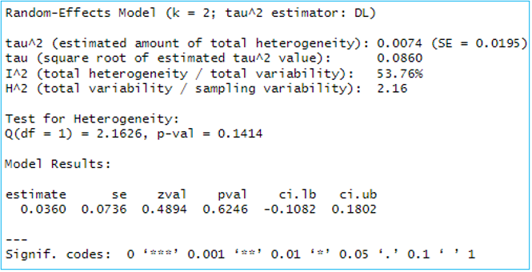
Supplementary Figure 13: LTCF Pooled Risk Difference, DerSimonian-Laird Model.

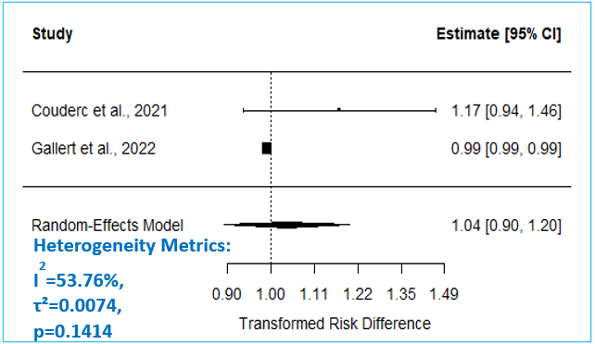
Supplementary Figure 14: LTCF Risk Difference Forest Plot.

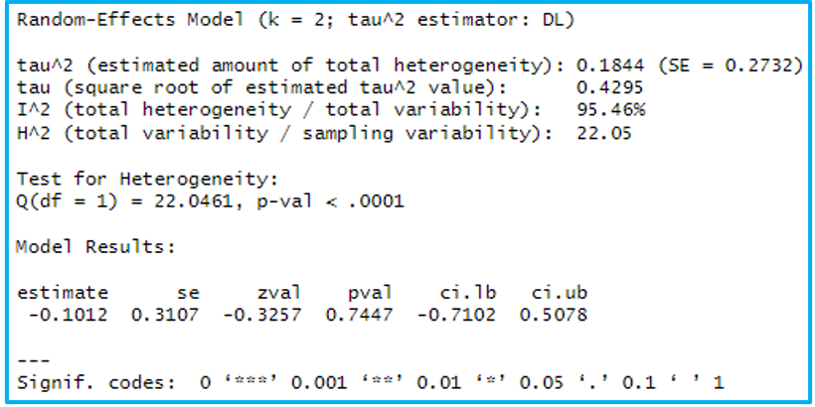
Supplementary Figure 15: Home Dwelling Centenarians Pooled Odds Ratio.

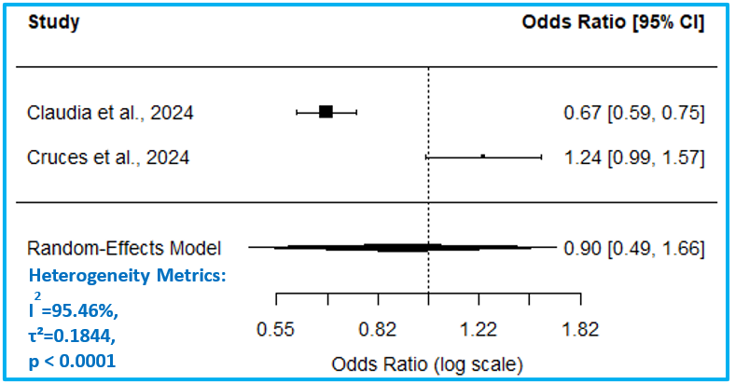
Supplementary Figure 16: Home Dwelling Centenarians Odds Ratio Forest Plot.

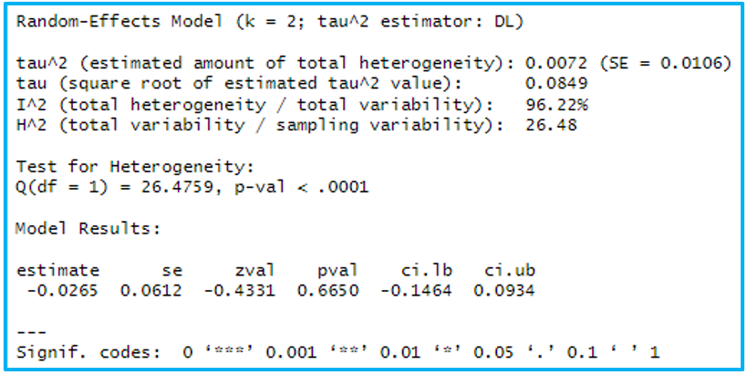
Supplementary Figure 17: Home Dwelling Centenarians Pooled Risk Difference.

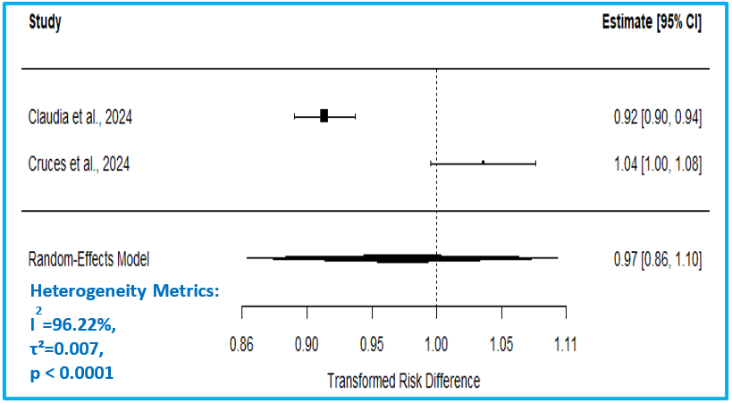
Supplementary Figure 18: Home Dwelling Centenarians Risk Difference Forest Plot.

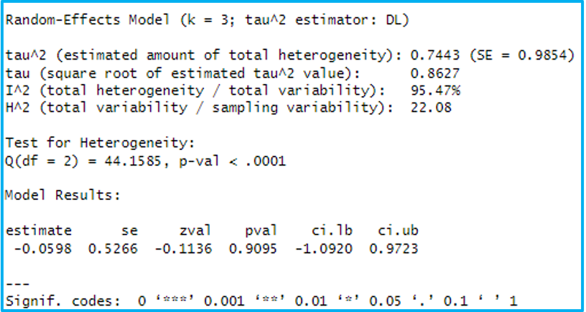
Supplementary Figure 19: Centenarians in Developed Countries Pooled Odds Ratio.

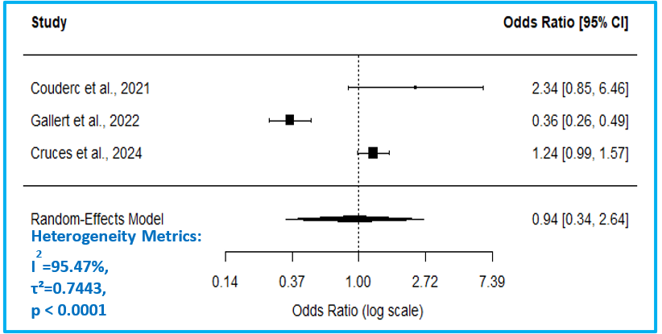
Supplementary Figure 20: Centenarians in Developed Countries Odds Ratio Forest Plot.

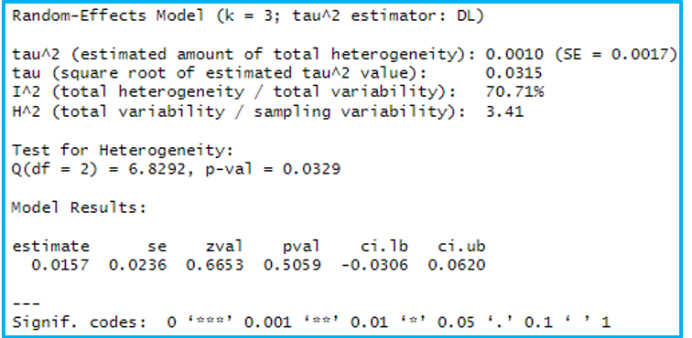
Supplementary Figure 21: Centenarians in Developed Countries Pooled Risk Difference.

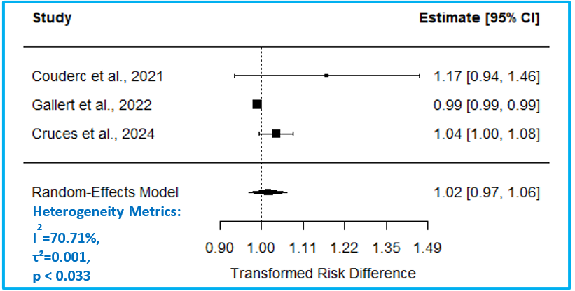
Supplementary Figure 22: Centenarians in Developed Countries Risk Difference Forest Plot.

